HTML and CSS basics – Revision (self-paced learning activity)

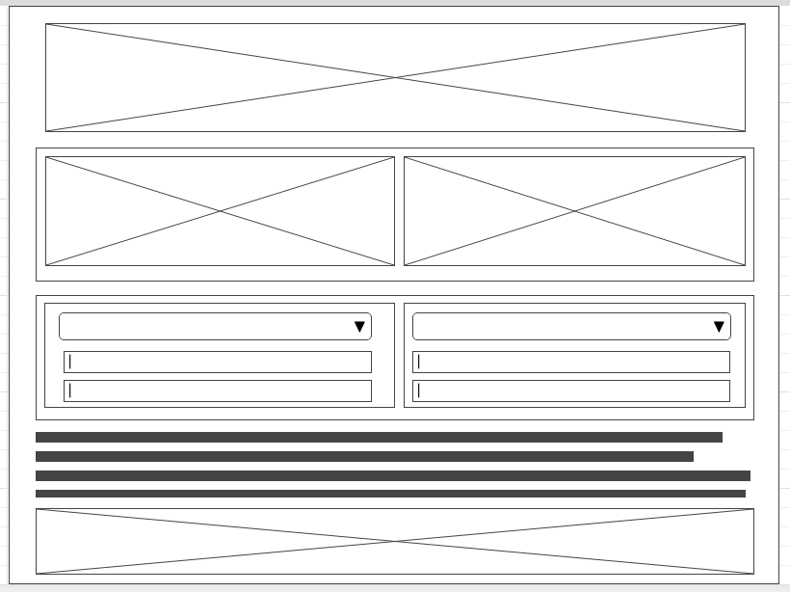

|  |  |  |
| --- | --- | --- |
| **Serial No.** | **Steps** | **Commands needed** |
|  | Create a folder on desktop called web-basics | 1. Right click and select new folder 2. Rename the folder as web-basics |
|  | Create an index.html inside this folder | 1. Open SublimeText or any other editor 2. Drag the folder you created on to it 3. Right click on the folder and select new file 4. Save it as index.html |
|  | Create a folder in there and call it css | 1. Right click on the folder again 2. Select new folder 3. Name it as css |
|  | Create a file inside css and call it style.css | 1. Right click on the css folder 2. Select new file 3. Save it as style.css |
|  | Bring html boiler plate inside index.html  (enter html and press tab key to get the boiler plate) | <!DOCTYPE html>  <html>  <head>  <title>Basics</title>    </head>  <body>  </body>  </html> |
|  | Link your style.css file. Enter the tag inside the head section | <link rel="stylesheet" href="css/style.css"/> |
|  | Create div(s) for the wireframe given above in html file. These tags are entered inside body tag. | <div>  <h1> <h1>  </div> |
|  | Add suitable selectors/attributes to divs. | <div id=” “ >  </div>  <div class=” “ >  </div> |
|  | Open style.css file and enter css resets | *{  margin : 0;  padding : 0;  box-sizing : border-box;  } |
|  | Add styles to the div(s)-limit to dimensions, background color and few other “must have” attributes | {  width: ;  height: ;  background-color: ;  } |
|  | At the end you must achieve the given wireframe structure for your web site |  |

Css color names : tomato, teal, slateBlue, didgerblue, gray, mediumseagreen